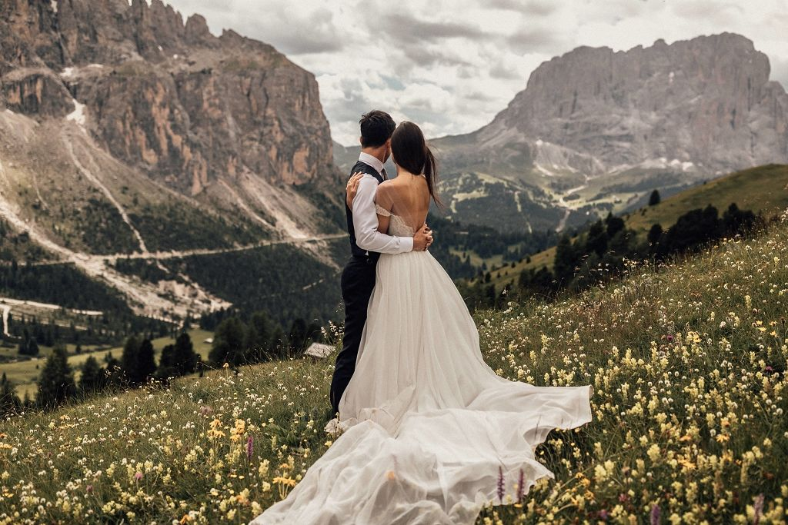
@ndcseppi and @paul.seppi met at the law firm they were both working at in London. “We aren’t the likeliest of couples, given that we come from two different continents, and our first languages aren’t even the same!” Natalie says. Around three years of dating later, and Paul got down on one knee at the beach in Hong Kong.

Being based in Hong Kong now, the couple relied on Paul’s parents to help find a venue in their home region of South Tyrol in Italy. They suggested @schloss_freudenstein and to help plan it all, they hired @laurabravievents and @biancoantico.
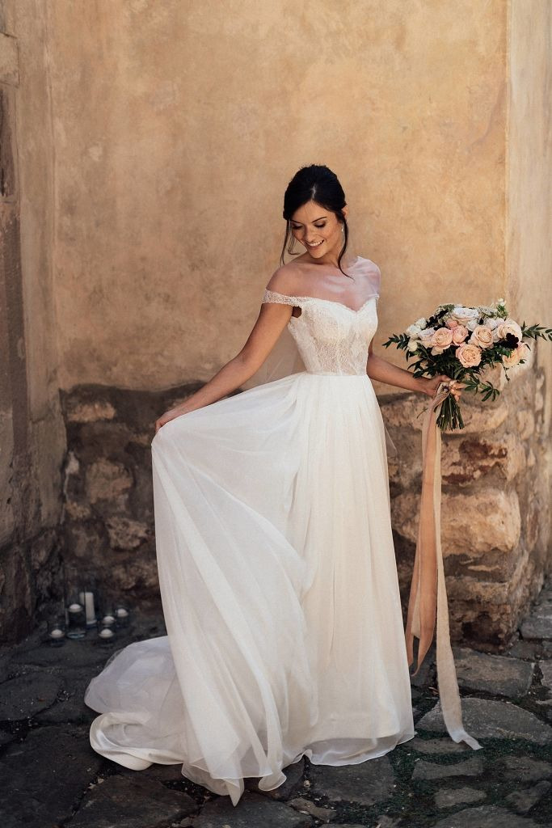
Natalie enlisted her mother’s long-time tailor in Singapore to create her gown. “I wanted an off-the-shoulder dress with a lace bodice, A-line skirt, and deep v in the back.”

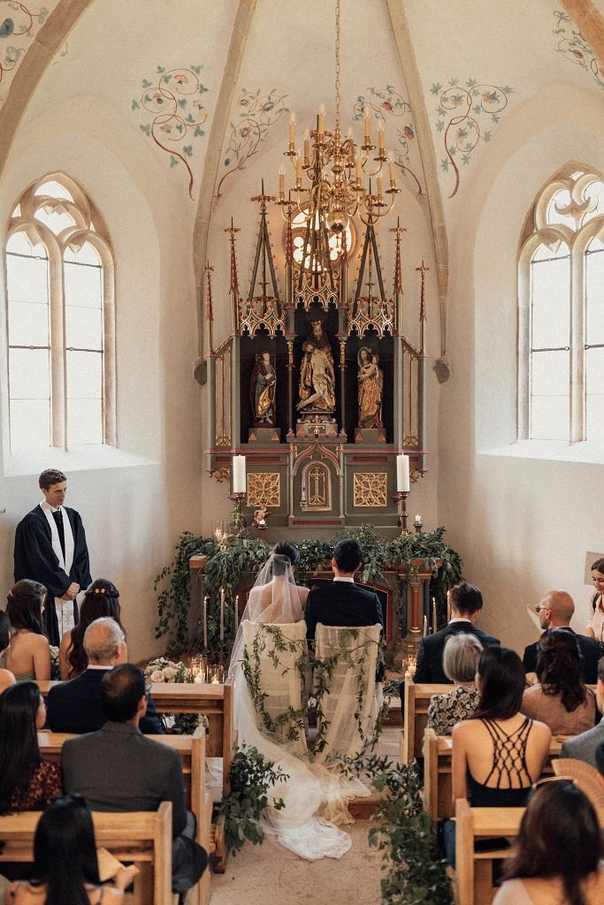
“Us in the chapel, just before exchanging our vows in front of our friends and family.”

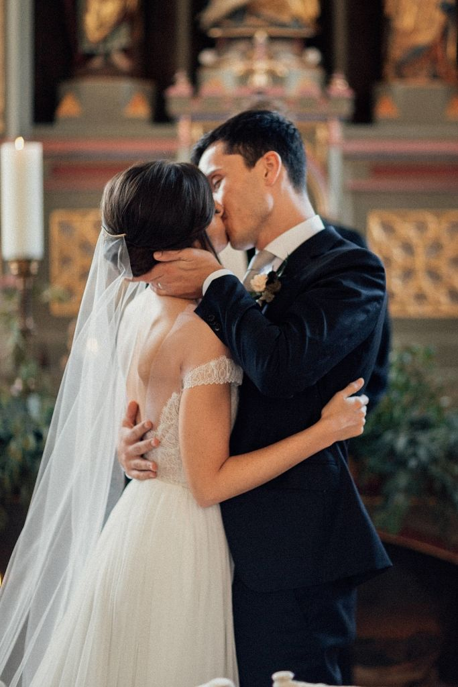
“Our first kiss as husband and wife!”

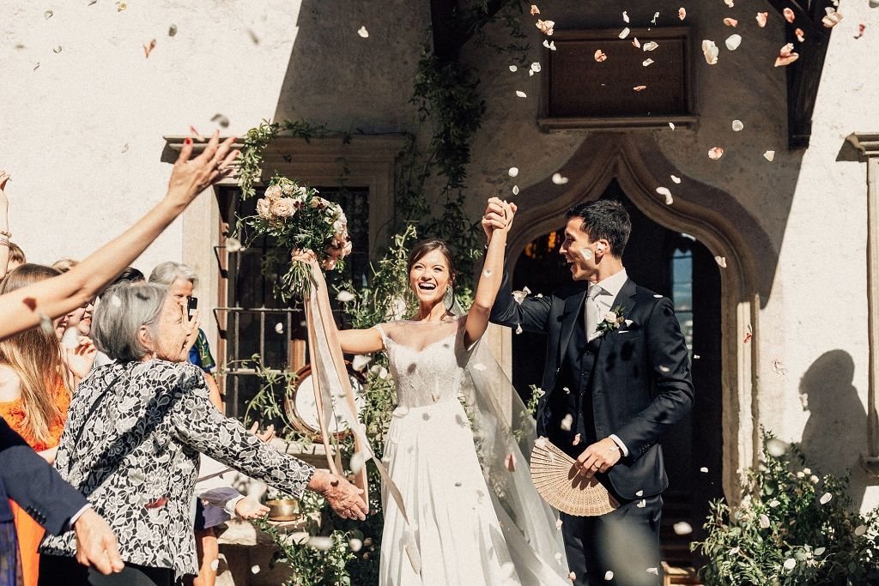
“Pure joy! Paul’s grandmother enthusiastically tossing confetti at us—excellent arm strength for an 88 year old!”

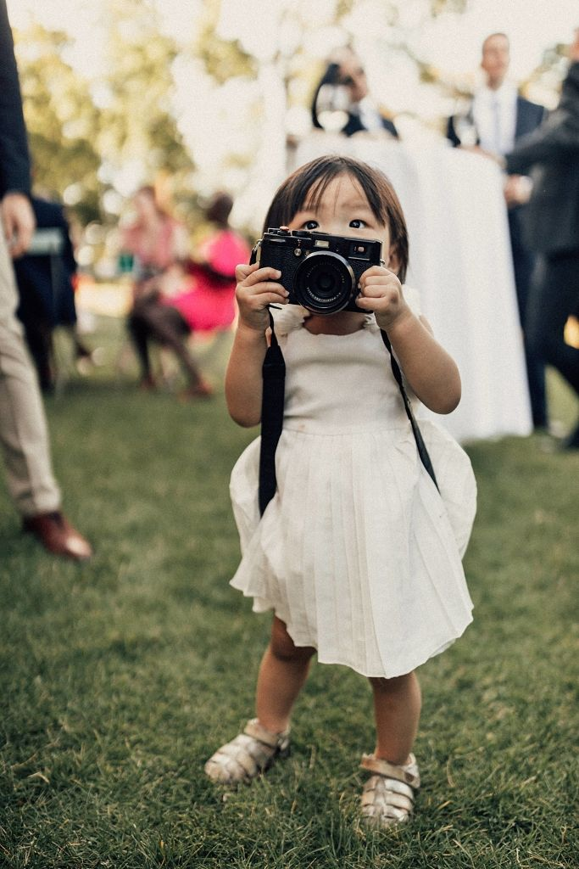
“Baby Emma getting in on the photo taking action!”
Photo: @melliandshayne

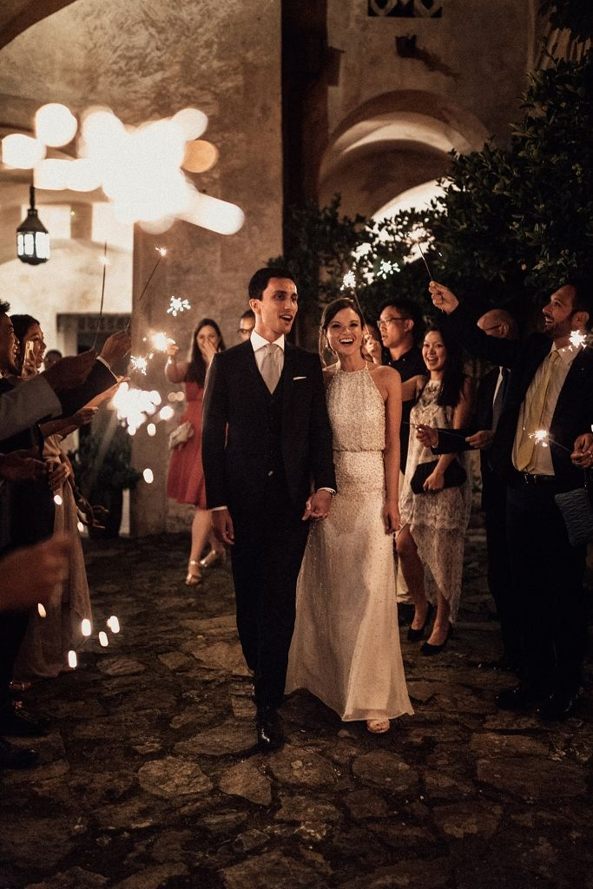
“Sparkler time en route to our wedding cake and dessert in the courtyard!”

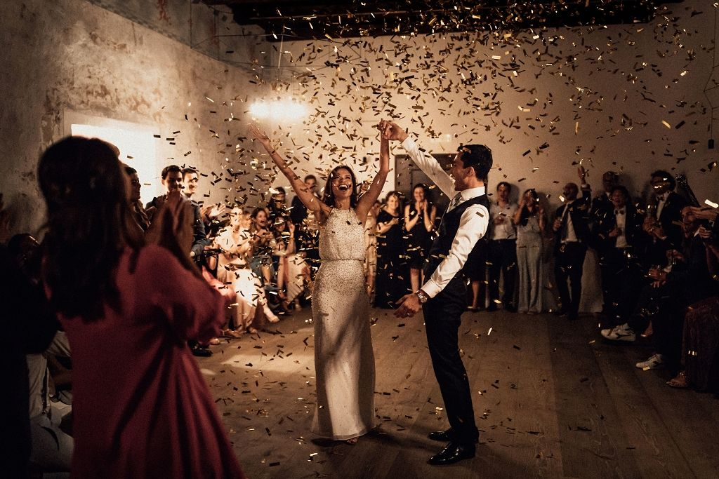
“Post-first dance—we were clearly ecstatic to get through it without stepping on each other’s toes!”

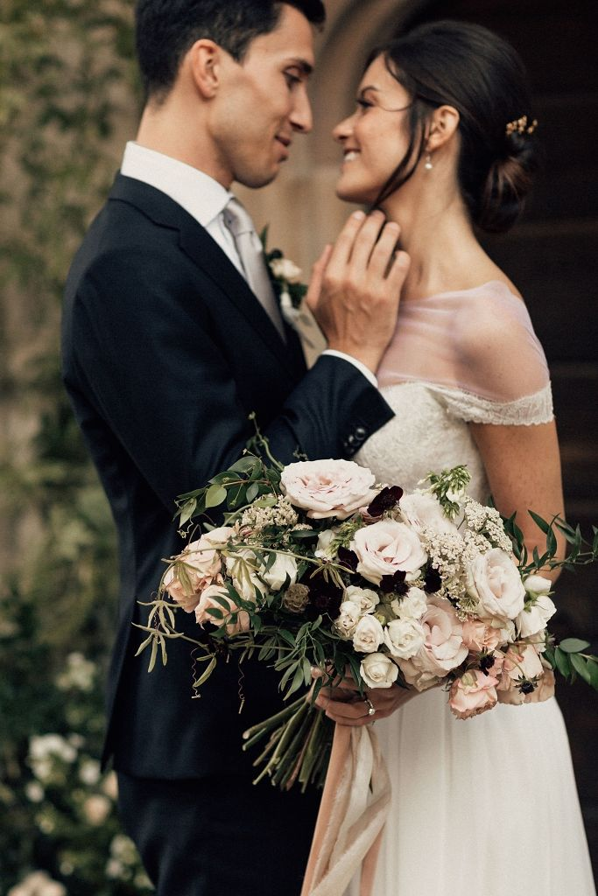
Swipe up to see more of this Italy wedding!
Photo: @melliandshayne

